Step-by-Step Workflow
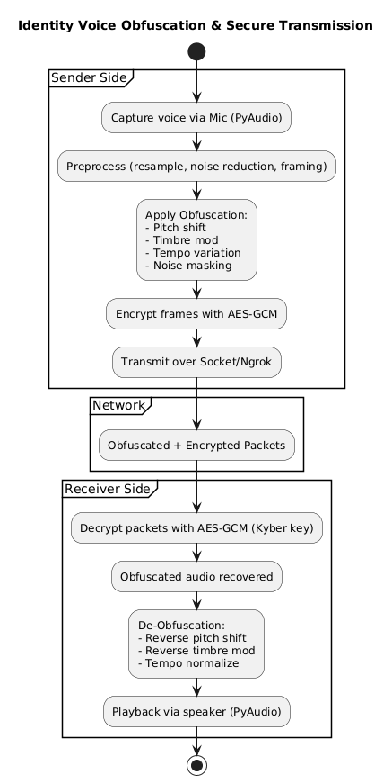
🔊 Step 1: Voice Capture
- Microphone captures analog sound waves.
- Converted to digital waveform using ADC (Audio Driver).
- Sampling Rate: e.g., 16 kHz, 16-bit PCM → balances quality vs. bandwidth.
- Tool: PyAudio captures real-time audio frames (~50 ms each).
📦 Data format: Array of amplitude values
x[n],n=0,1,2,…x[n], \quad n=0,1,2,\dotsx[n],n=0,1,2,…

🎚 Step 2: Preprocessing
- Resampling → Normalize to a fixed rate (e.g., 16 kHz).
- Noise reduction → Remove background noise (FFT filtering).
- Frame division → Split into small frames (20–50 ms) → ensures low latency.
- Tools: numpy, pydub, librosa.
📦 Output: clean, framed digital audio chunks.

🎭 Step 3: Voice Obfuscation
Here’s where identity hiding happens:
- Pitch Shifting
  - Raise/lower pitch by a few semitones.
  - Example: Male voice → sounds female, but natural.
  - Formula (time-domain scaling):
y[n]=x[αn],α=new pitchoriginal pitchy[n] = x[\alpha n], \quad \alpha = \frac{\text{new pitch}}{\text{original pitch}}y[n]=x[αn],α=original pitchnew pitch​
- Timbre Modification
  - Change “color” of voice (resonances).
  - Achieved using formant shifting (vocal tract model).
  - Prevents biometric voiceprint matching.
- Speed Variation
  - Small tempo changes (±5%).
  - Breaks rhythm-based voice recognition.
- Optional Noise Masking
  - Add faint synthetic background (not audible to human, but confuses AI).
📦 Output: A distorted voice that carries the message but hides the identity.

🔒 Step 4: Encryption & Transmission
- Distorted voice frames → encrypted with AES-GCM.
- Session key generated via Kyber KEM (post-quantum secure).
- Data sent over network using:
  - Sockets for local connections
  - Ngrok tunnel for cross-network (Wi-Fi ↔ 4G).
📦 Output: Obfuscated & encrypted audio packets.

📡 Step 5: Reception & Decryption
- Receiver gets packets (ciphertext, auth_tag).
- Decrypts with AES-GCM using the shared key m (from Kyber).
- Recovered distorted audio stream (same obfuscation applied).
📦 Output: Distorted audio (still identity-hidden).

🎙 Step 6: De-Obfuscation (Restoration)
- Receiver applies reverse DSP transforms to restore original:
- Pitch Reversal → If sender raised pitch by +3 semitones, receiver lowers it by -3 semitones.
- Formant Reversal → Apply inverse mapping to restore timbre.
- Tempo Normalization → Reset back to original speed.
📦 Output: Restored voice, close to original speaker.

🔊 Step 7: Playback
- Receiver hears clear, natural voice of the original speaker.
- Delay kept minimal (~100 ms end-to-end).
- Tools: PyAudio real-time playback.

